LAB 9 TASK


Web Engineering
Submitted by: HASSAN SHAH
Roll No: 2410_0099
Batch: BSCS SPRING 2024

“On my honor, as student of Sir Syed CASE Institute Islamabad, I have neither given nor received unauthorized assistance on this academic work.”

Submitted to:
SIR HASSAN SHAH
DATE:
26-04-2026

ROOT App.js code
import React, { useState } from 'react';
import Lab8App from './lab8/App';
import Lab9App from './lab9/App';

function App() {
const [currentLab, setCurrentLab] = useState('lab8'); // default Lab 8

return (
<div>
{/* Dropdown for switching */}
<select
value={currentLab}
onChange={(e) => setCurrentLab(e.target.value)}
style={{ margin: '20px', padding: '5px' }}
>
<option value="lab8">Lab 8</option>
<option value="lab9">Lab 9</option>
</select>

{/* Render selected lab */}
{currentLab === 'lab8' && <Lab8App />}
{currentLab === 'lab9' && <Lab9App />}
</div>
);
}

export default App;

lab 9 App.js code :
import React from 'react';
import Navbar from './Navbar';
import HeroSection from './HeroSection';
import TeamSection from './TeamSection';

function App() {
return (
<div className="bg-gradient-to-r from-slate-900 via-blue-900 to-indigo-900 min-h-screen text-white">
<Navbar />
<HeroSection />
<TeamSection />
</div>
);
}

export default App;

App.css :
.App {
font-family: 'Segoe UI', Tahoma, Geneva, Verdana, sans-serif;
background: linear-gradient(to right, #1e3c72, #2a5298);
min-height: 100vh;
color: #fff;
text-align: center;
}

nav {
background-color: #0f172a;
padding: 15px;
font-size: 18px;
font-weight: bold;
color: #38bdf8;
}

section {
padding: 40px 20px;
}

.hero {
background: linear-gradient(to right, #06b6d4, #3b82f6);
padding: 60px 20px;
border-radius: 10px;
}

.team {
background-color: #1e293b;
border-radius: 10px;
padding: 40px 20px;
}
Navbar.js
import React from 'react';

function Navbar() {
return (
<nav className="bg-slate-800 shadow-lg p-4 flex justify-between items-center">
<h1 className="text-xl font-bold text-cyan-400"> Lab 9 Project</h1>
<ul className="flex gap-6 text-gray-300">
<li className="hover:text-cyan-400 cursor-pointer">Home</li>
<li className="hover:text-cyan-400 cursor-pointer">About</li>
<li className="hover:text-cyan-400 cursor-pointer">Team</li>
</ul>
</nav>
);
}

export default Navbar;

HeroSection.js
import React from 'react';

function HeroSection() {
return (
<section className="hero text-center py-20 bg-gradient-to-r from-cyan-500 to-blue-600 rounded-lg shadow-xl mx-6 mt-6">
<h1 className="text-4xl font-extrabold mb-4">Welcome to Lab 9</h1>
<p className="text-lg text-gray-100">
A professional Hero Section with gradient background, modern fonts, and responsive design.
</p>
<button className="mt-6 px-6 py-2 bg-indigo-700 hover:bg-indigo-500 rounded-lg text-white font-semibold shadow-md">
Get Started
</button>
</section>
);
}

export default HeroSection;

TeamSection.js
import React from 'react';

function TeamSection() {
return (
<section className="team bg-slate-800 rounded-lg shadow-lg mx-6 mt-10 p-10">
<h2 className="text-3xl font-bold text-cyan-400 mb-4">Our Team</h2>
<p className="text-gray-300 mb-6">Meet the amazing developers behind this project:</p>
<div className="grid grid-cols-1 md:grid-cols-3 gap-6">
<div className="bg-slate-700 p-6 rounded-lg hover:scale-105 transition-transform">
👨‍💻 Hassan Shah
</div>
<div className="bg-slate-700 p-6 rounded-lg hover:scale-105 transition-transform">
👩‍💻 Developer 2
</div>
<div className="bg-slate-700 p-6 rounded-lg hover:scale-105 transition-transform">
👨‍💻 Developer 3
</div>
</div>
</section>
);
}

export default TeamSection;

WEBPAGE :

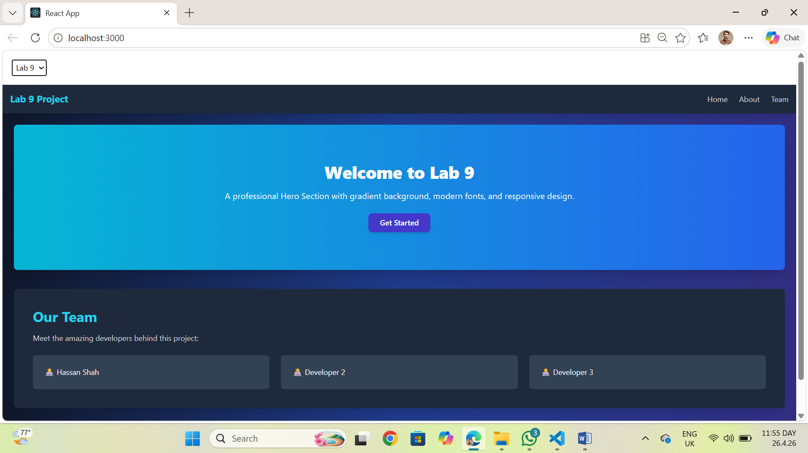

THE END!!!!!!

